**Pinterest** is a social network app that allows users to visually share, and discover new interests by posting (known as 'pinning' on Pinterest) images or videos to their own or others' boards (i.e. a collection of 'pins,' usually with a common theme) and browsing what other users have pinned.

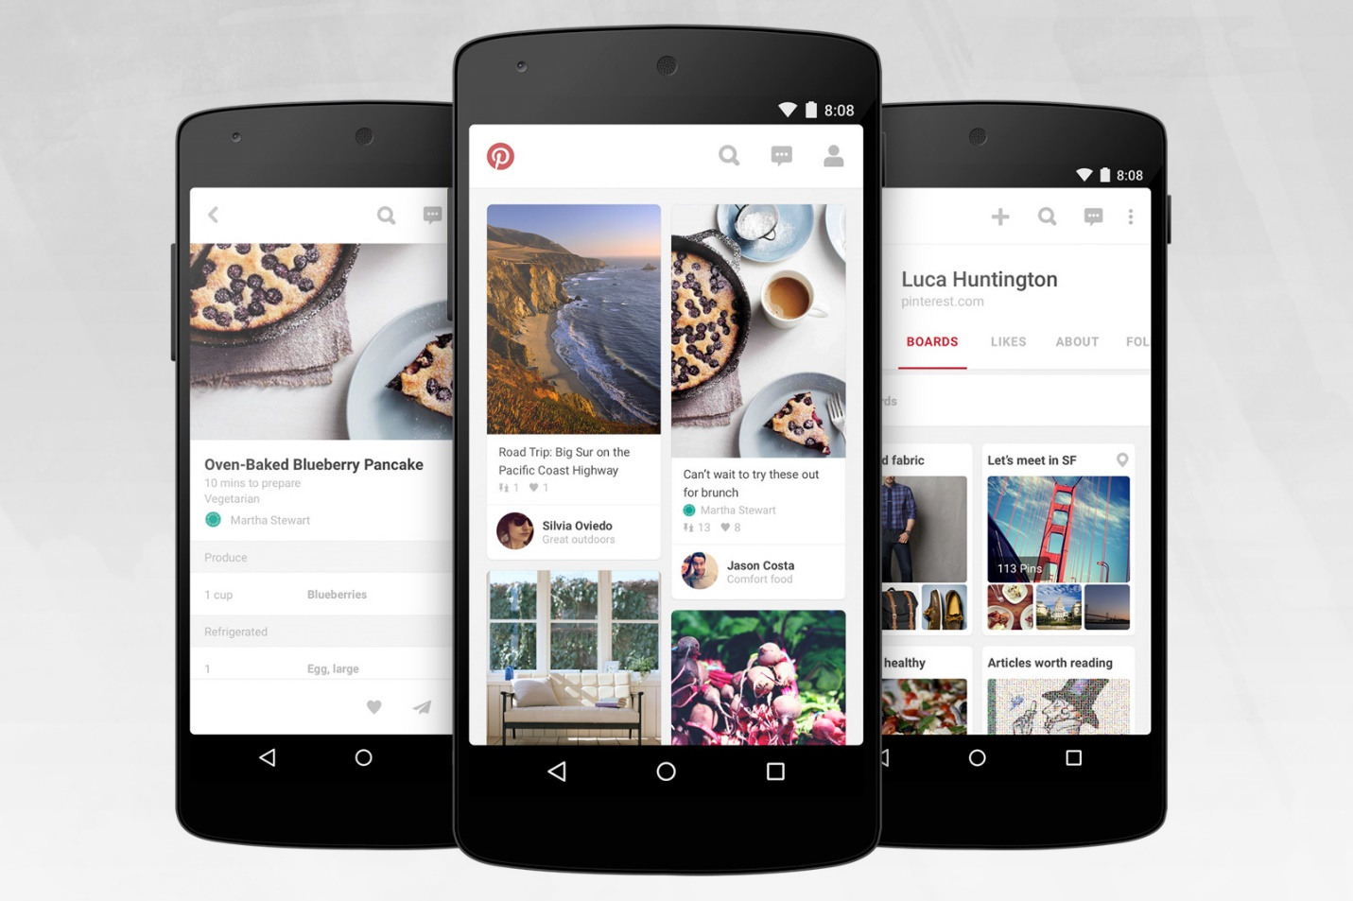

In this exam, you are trying to complete the design through the tools we learned in the mobile computing class. Your solution shall be as similar as possible to the figure in the next page. The image material to use can be found online with this link

<https://github.com/DrWeiChen/MobileComputing/blob/master/drawable_midterm_practice_exam.zip>

Please unzip the zipped file and put the images in the drawable folder to start.

Some important grading criterions are listed as follows:

1. App Name: Midterm Exam Practice
2. Pinterest Logo
3. Edit Text next to the Pinterest Logo
4. Image Buttons for Search, Message and Profile
5. Two Columns Layout
6. Image, Description, pin icon, heart icon and user profile for user 1
7. Image, Description, pin icon, heart icon and user profile for user 2
8. Margin between two columns

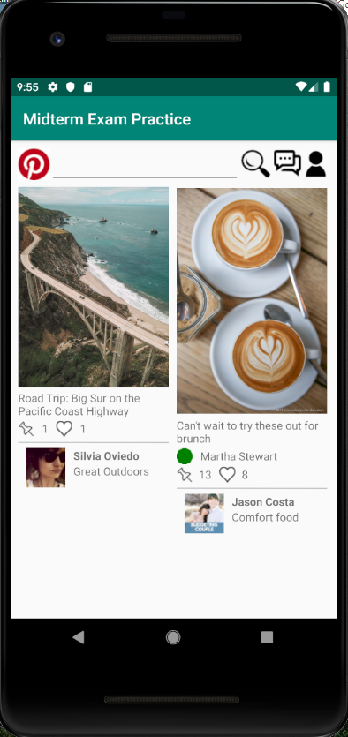

Solution:

*<?***xml version="1.0" encoding="utf-8"***?>*<**LinearLayout xmlns:android="http://schemas.android.com/apk/res/android"  
 android:orientation="vertical"  
 android:layout_width="match_parent"  
 android:layout_height="match_parent"  
 android:layout_margin="10dp"**>  
 <**LinearLayout  
 android:orientation="horizontal"  
 android:layout_width="match_parent"  
 android:layout_height="wrap_content"**>  
 <**ImageView  
 android:layout_width="wrap_content"  
 android:layout_height="wrap_content"  
 android:src="@drawable/pinterest_icon"**/>  
 <**EditText  
 android:layout_width="240dp"  
 android:layout_height="wrap_content"** />  
 <**ImageButton  
 android:layout_width="wrap_content"  
 android:layout_height="wrap_content"  
 android:src="@drawable/search_icon"  
 android:background="#FAFAFA"**/>  
 <**ImageButton  
 android:layout_width="wrap_content"  
 android:layout_height="wrap_content"  
 android:src="@drawable/message_icon"  
 android:background="#FAFAFA"**/>  
 <**ImageButton  
 android:layout_width="wrap_content"  
 android:layout_height="wrap_content"  
 android:src="@drawable/profile_icon"  
 android:background="#FAFAFA"**/>  
 </**LinearLayout**>

<**LinearLayout  
 android:layout_width="match_parent"  
 android:layout_height="wrap_content"**>  
  
 <**LinearLayout  
 android:layout_width="190dp"  
 android:layout_height="wrap_content"  
 android:orientation="vertical"**>  
 <**ImageView  
 android:layout_width="match_parent"  
 android:layout_height="260dp"  
 android:src="@drawable/image1"**/>  
 <**TextView  
 android:layout_width="match_parent"  
 android:layout_height="wrap_content"  
 android:text="Road Trip: Big Sur on the Pacific Coast Highway"**/>  
 <**LinearLayout  
 android:layout_width="match_parent"  
 android:layout_height="wrap_content"  
 android:layout_marginTop="3dp"**>  
 <**ImageView  
 android:layout_width="wrap_content"  
 android:layout_height="wrap_content"  
 android:src="@drawable/pin_icon"**/>  
 <**TextView  
 android:layout_width="wrap_content"  
 android:layout_height="wrap_content"  
 android:text="1"  
 android:layout_marginLeft="10dp"**/>  
 <**ImageView  
 android:layout_width="wrap_content"  
 android:layout_height="wrap_content"  
 android:src="@drawable/heart_icon"  
 android:layout_marginLeft="10dp"**/>  
 <**TextView  
 android:layout_width="wrap_content"  
 android:layout_height="wrap_content"  
 android:text="1"  
 android:layout_marginLeft="10dp"**/>  
 </**LinearLayout**>

<**ImageView  
 android:layout_width="match_parent"  
 android:layout_height="wrap_content"  
 android:src="@drawable/gray_line"**/>  
 <**LinearLayout  
 android:layout_width="match_parent"  
 android:layout_height="wrap_content"  
 android:orientation="horizontal"**>  
 <**ImageView  
 android:layout_width="wrap_content"  
 android:layout_height="wrap_content"  
 android:src="@drawable/user1"  
 android:layout_marginLeft="10dp"**/>  
 <**LinearLayout  
 android:layout_width="wrap_content"  
 android:layout_height="wrap_content"  
 android:orientation="vertical"**>  
 <**TextView  
 android:layout_width="wrap_content"  
 android:layout_height="wrap_content"  
 android:text="Silvia Oviedo"  
 android:textStyle="bold"  
 android:layout_marginLeft="10dp"**/>  
 <**TextView  
 android:layout_width="wrap_content"  
 android:layout_height="wrap_content"  
 android:text="Great Outdoors"  
 android:layout_marginLeft="10dp"**/>  
 </**LinearLayout**>  
 </**LinearLayout**>  
 </**LinearLayout**>  
  
 <**LinearLayout  
 android:layout_width="190dp"  
 android:layout_height="wrap_content"  
 android:orientation="vertical"  
 android:layout_marginLeft="10dp"**>  
  
 <**ImageView  
 android:layout_width="match_parent"  
 android:layout_height="295dp"  
 android:src="@drawable/image2"**/>  
 <**TextView  
 android:layout_width="match_parent"  
 android:layout_height="wrap_content"  
 android:text="Can't wait to try these out for brunch"**/>  
 <**LinearLayout  
 android:layout_width="match_parent"  
 android:layout_height="wrap_content"  
 android:layout_marginTop="3dp"  
 android:layout_marginBottom="3dp"**>  
 <**ImageView  
 android:layout_width="wrap_content"  
 android:layout_height="wrap_content"  
 android:src="@drawable/green_icon"**/>  
 <**TextView  
 android:layout_width="wrap_content"  
 android:layout_height="wrap_content"  
 android:layout_marginLeft="10dp"  
 android:text="Martha Stewart"**/>  
 </**LinearLayout**>

<**LinearLayout  
 android:layout_width="match_parent"  
 android:layout_height="wrap_content"**>  
 <**ImageView  
 android:layout_width="wrap_content"  
 android:layout_height="wrap_content"  
 android:src="@drawable/pin_icon"**/>  
 <**TextView  
 android:layout_width="wrap_content"  
 android:layout_height="wrap_content"  
 android:text="13"  
 android:layout_marginLeft="8dp"**/>  
 <**ImageView  
 android:layout_width="wrap_content"  
 android:layout_height="wrap_content"  
 android:src="@drawable/heart_icon"  
 android:layout_marginLeft="10dp"**/>  
 <**TextView  
 android:layout_width="wrap_content"  
 android:layout_height="wrap_content"  
 android:text="8"  
 android:layout_marginLeft="8dp"**/>  
 </**LinearLayout**>

<**ImageView  
 android:layout_width="match_parent"  
 android:layout_height="wrap_content"  
 android:src="@drawable/gray_line"**/>

<**LinearLayout  
 android:layout_width="match_parent"  
 android:layout_height="wrap_content"  
 android:orientation="horizontal"**>  
 <**ImageView  
 android:layout_width="wrap_content"  
 android:layout_height="wrap_content"  
 android:src="@drawable/user2"  
 android:layout_marginLeft="10dp"**/>  
 <**LinearLayout  
 android:layout_width="wrap_content"  
 android:layout_height="wrap_content"  
 android:orientation="vertical"**>  
 <**TextView  
 android:layout_width="wrap_content"  
 android:layout_height="wrap_content"  
 android:text="Jason Costa"  
 android:textStyle="bold"  
 android:layout_marginLeft="10dp"**/>  
 <**TextView  
 android:layout_width="wrap_content"  
 android:layout_height="wrap_content"  
 android:text="Comfort food"  
 android:layout_marginLeft="10dp"**/>  
 </**LinearLayout**>  
  
 </**LinearLayout**>  
  
 </**LinearLayout**>  
  
 </**LinearLayout**>

</**LinearLayout**>